Editing First Pass
Step 1: Organize Your Media
• Import Footage & Audio
• Open Premiere Pro (or editing software of choice) and create a new project.
• Go to File > Import, then select your raw video and external audio files.
• Use the Media Browser to drag files into your project.
• Create Bins for Organization
• In the Project Panel (right-click > bin) to create folders (bins) for each interviewee: ex.
(Title of new bin) 3-22-25 Ann E. Moore (pic 1a)

(Folder title inside new bin) Ann E. Moore Interview (pic 1b)

(Folders Inside new folder) Video (Cam 1, 2 Ann E Moore’s Interview) (pic 1c)
Audio (External Audio clips)
Sequence (Interview/group question sequences)
Graphics (if needed)

Step 2: Sync Audio & Video
• Manually Sync audio using visual Slate and Waveforms, and audible clap from the slate (pics 2a 2b)
• Drag from folders, Clips (cam 1, cam 2) and audio (external Audio clips) onto the timeline. (3 Clips) (pics 2c 2d 2e)
• In the Timeline Panel, expand waveforms by clicking the drop-down arrow on the tracks. (Pic 2f)
• Visually match the peaks of the camera’s scratch audio (recorded audio from camera) with the external audio and match slates clap by listening to each audio track frame by frame trimming to the exact frame of the clap. Repeat on all 3 clips. (pic 2g)
• Once audio is aligned, unlink camera’s scratch audio (Right-click > Unlink) or lock video lines and external audio lines. (pic 2h)
• Select unlocked audio lines, press delete. (pic 2i)

Step 3: Organizing Synced Clips
• Clean up and group time line by dragging external audio onto audio track 1 and selecting all clips and (Right-click > Group) (pic 3a)
• listen to synced clips
• Cut interviewers voice out - “clips (IN point)” starts clip at interviewee answering the question with a complete sentence. And then “clips (OUT point)” ending clip before the start of the next question from the interviewer. (pic 3b)
• Right-click on each clip and rename (copy & paste) it something clear like: “My name is” or something relatable to the question (pic 3c)
• Group the renamed synced clips
• Select the renamed synced video and audio clips, then (right-click > Group). (pic 3d)
• Repeat Step 3 until you have essentially grouped each question of the interview completing the first pass. (pic 3e)

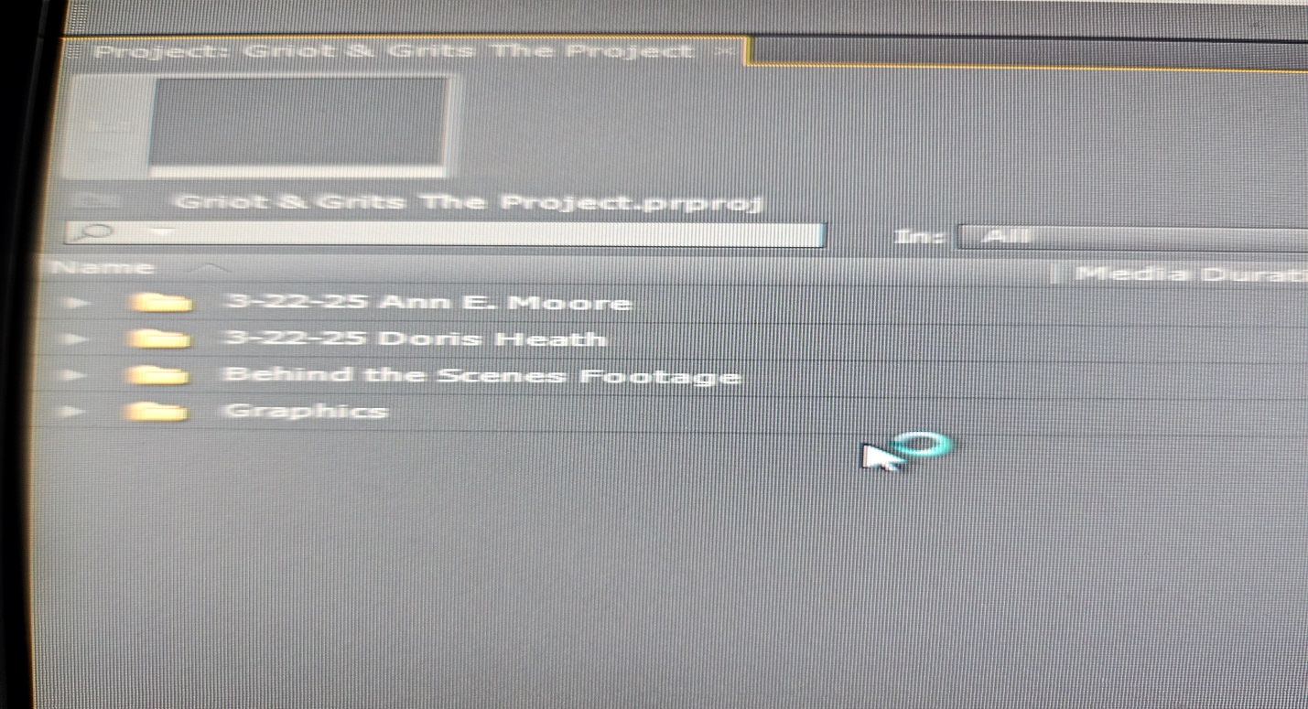
(pic 1 a) Ann E. Moore folder (and others being created)

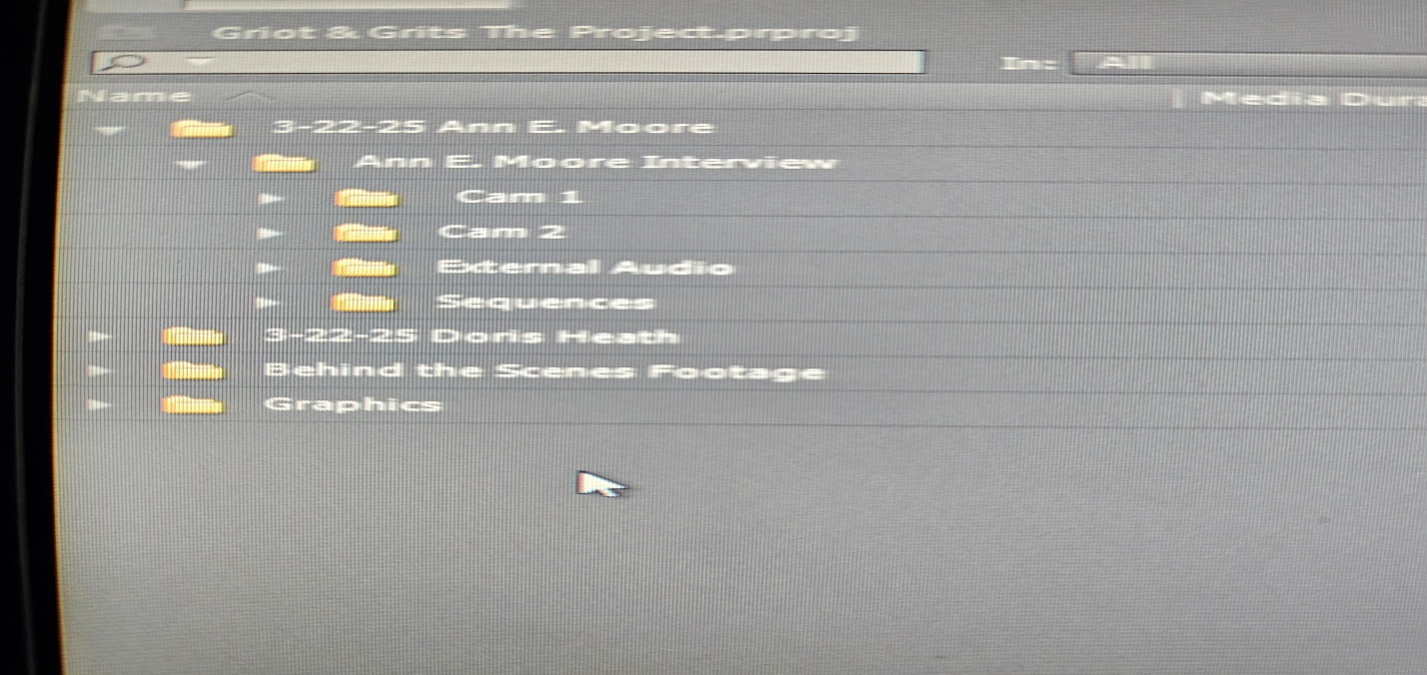
(pic 1b) Anne E. Moore Interview folder expanded

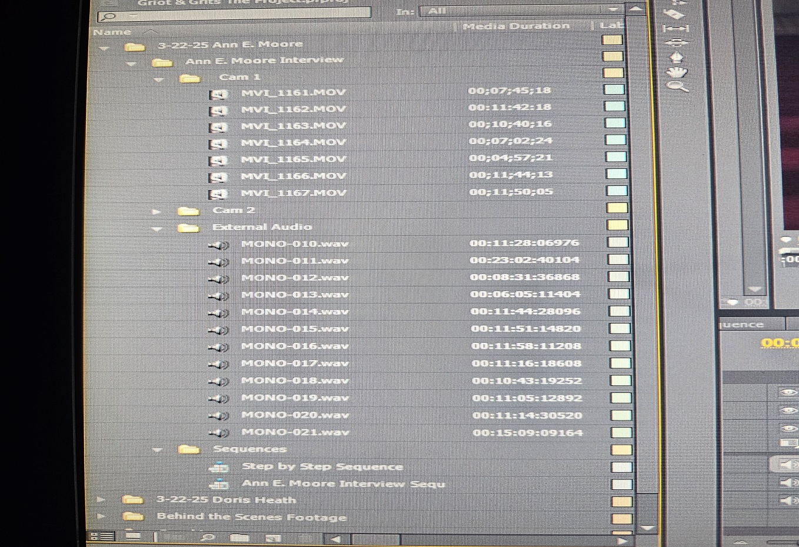
(pic 1c) Ann E. Moore Interview expanded

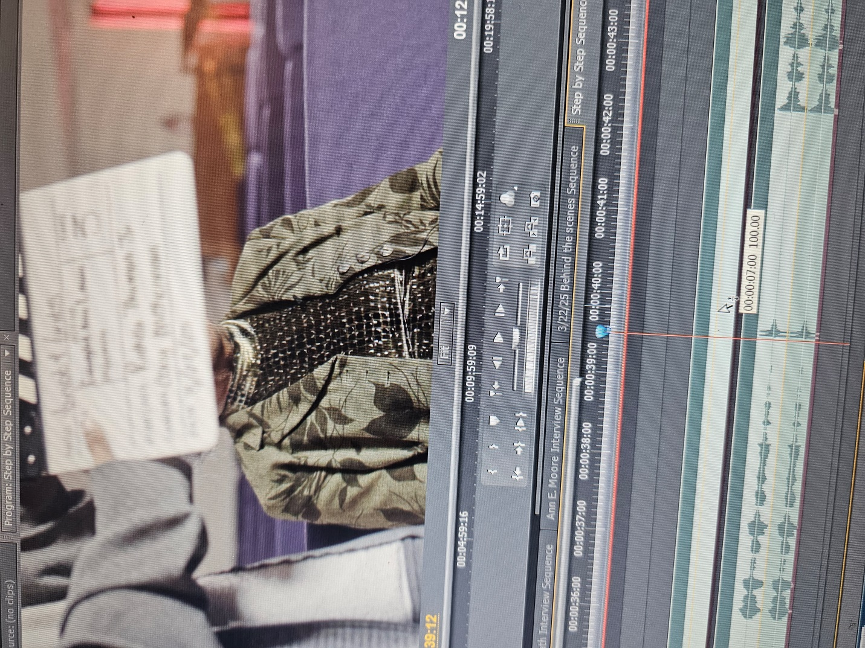
(pic 2a) camera 1 audio wave line. Curser is placed right before the slate claps (trim each video to this point)

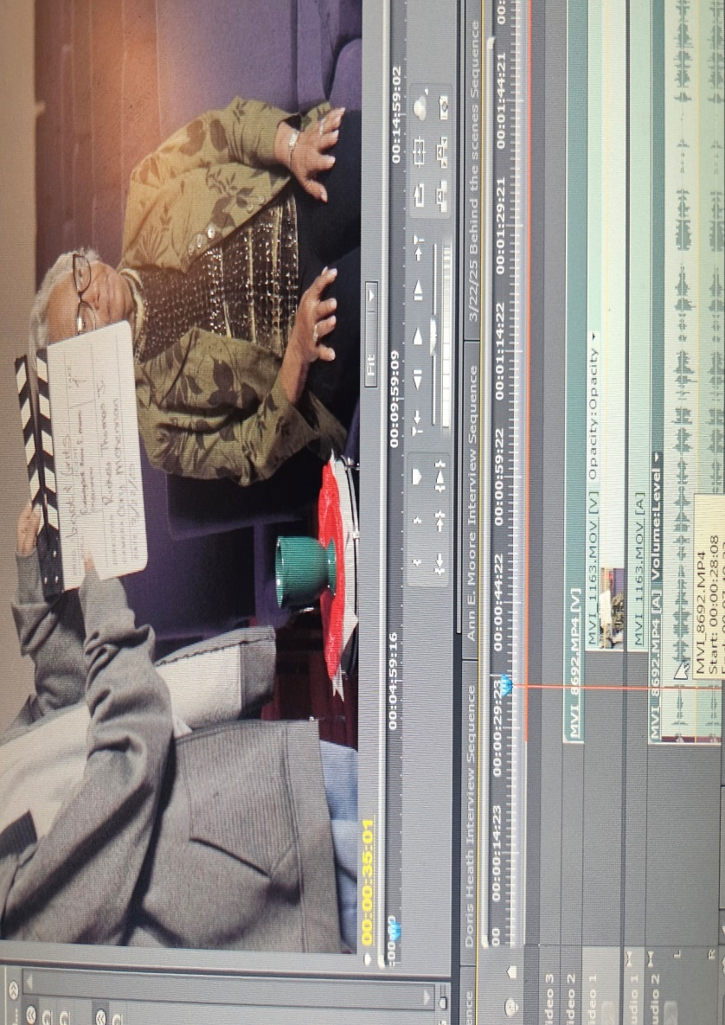
(pic 2b) Slate visually seen to assist with syncing audio and video lines

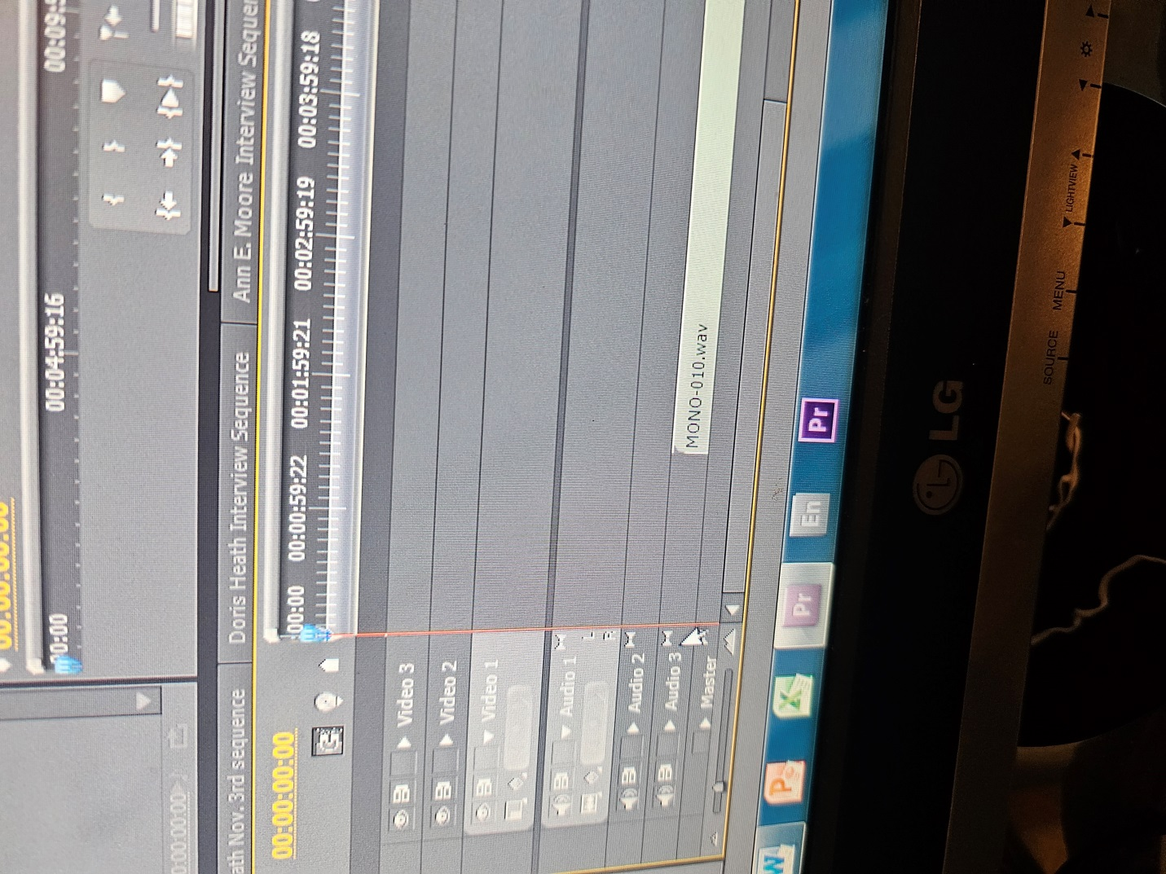
(pic 2c) External Audio dragged to audio 3 track on timeline
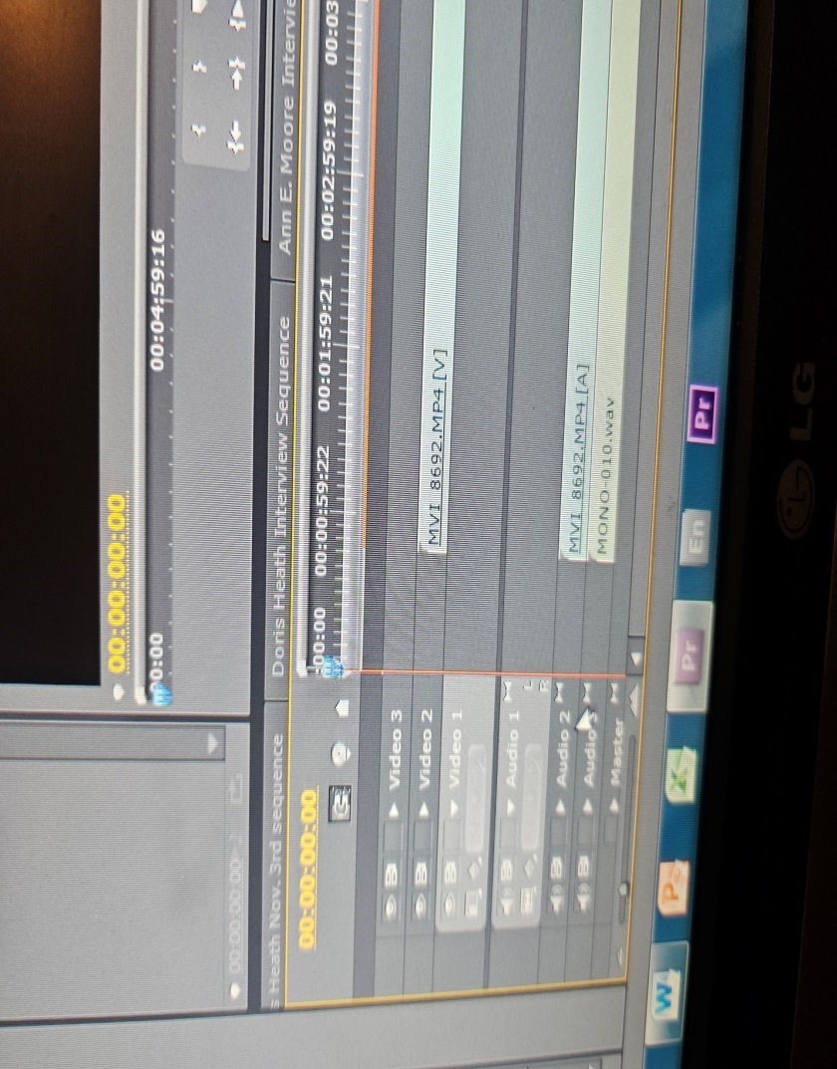
(pic 2d) Camera 2 dragged to video 2 track on timeline

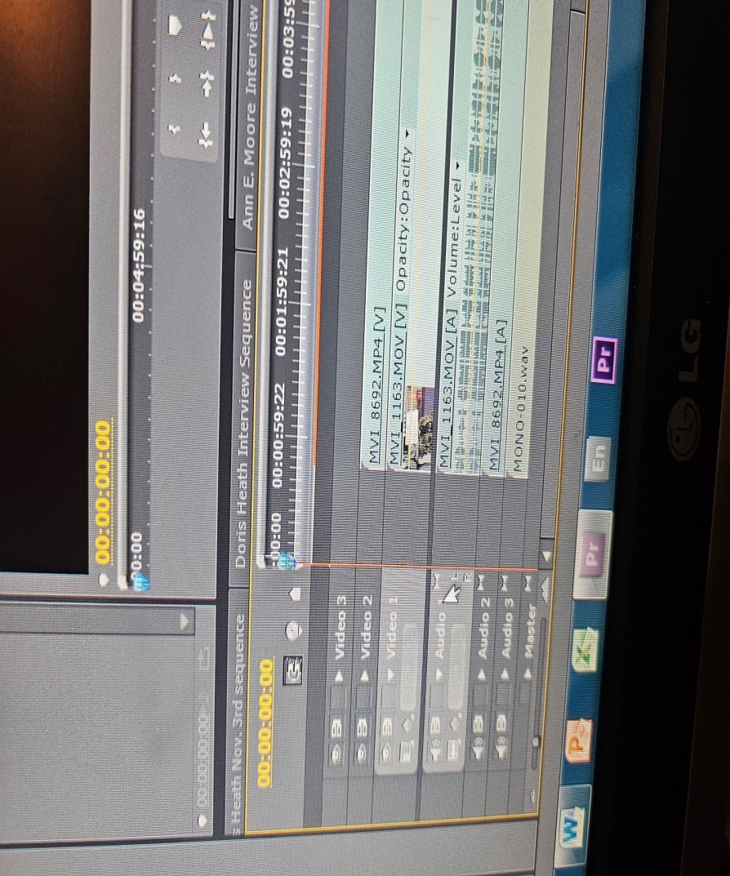
(pic 2e) Camera 1 dragged to video track 1 on timeline

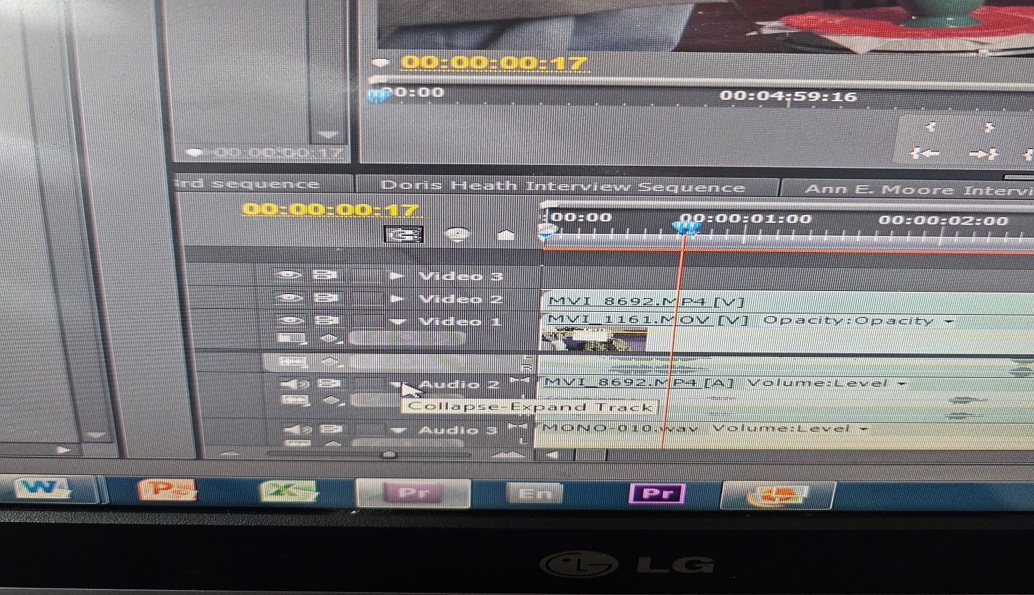
(pic 2f) drop down tab to expand audio track

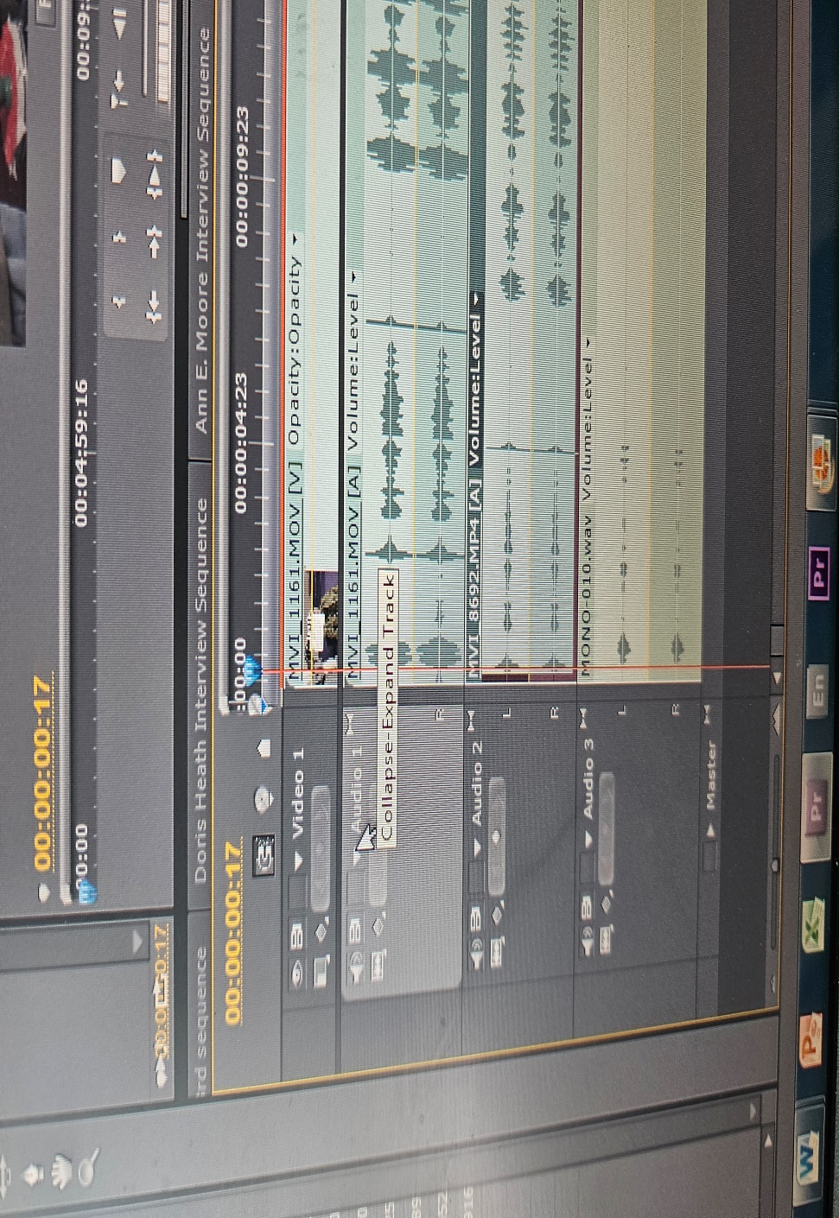
(pic 2g) Audio lines expanded to see audio peaks at slates clap
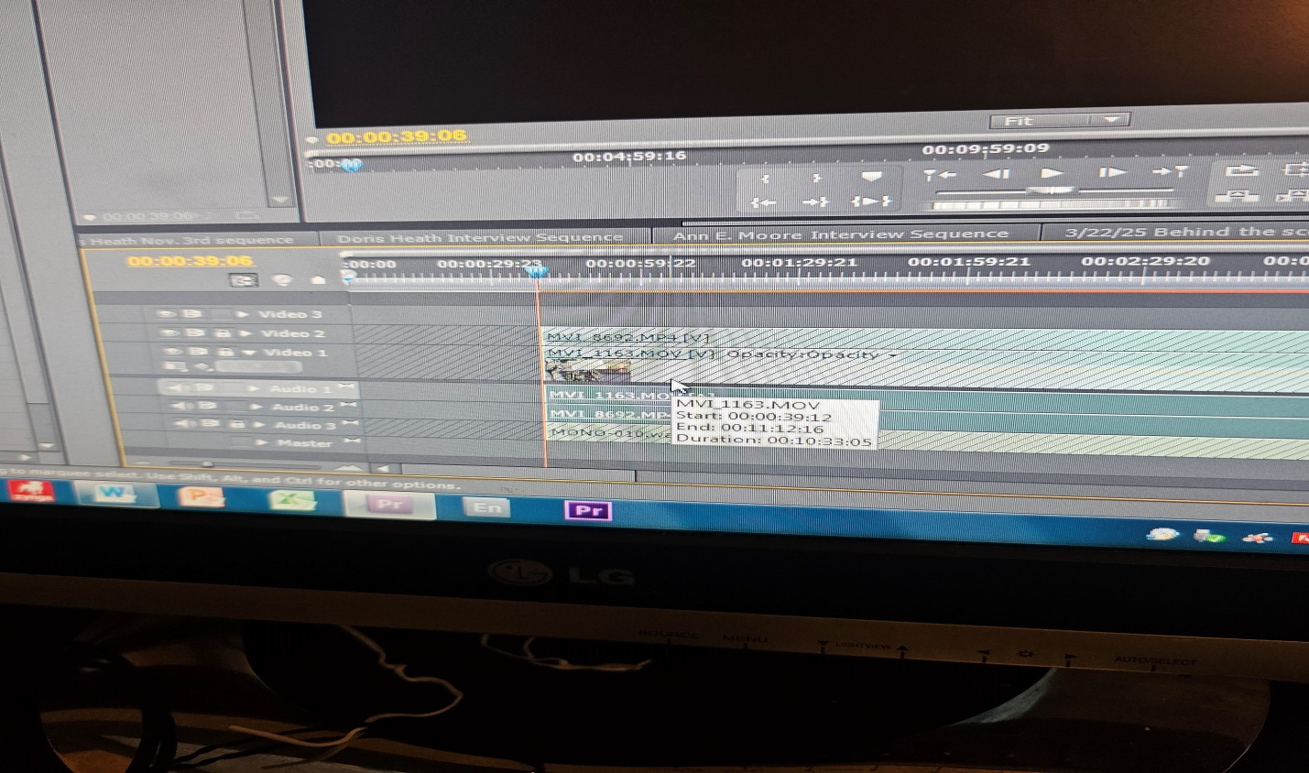
(pic 2h) Locking video and audio tracks we keep and selecting unwanted tracks

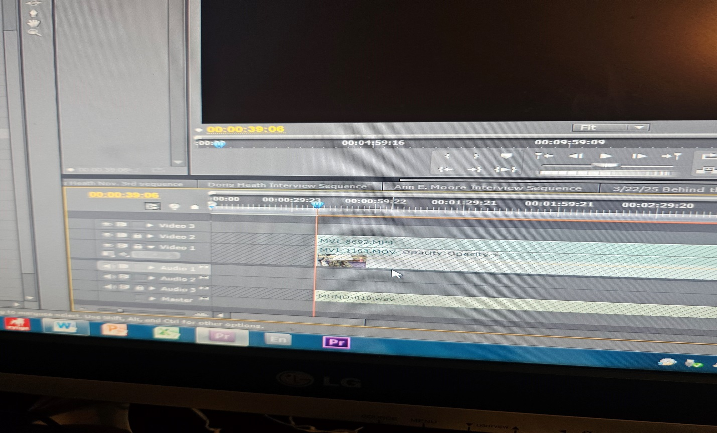
(pic 2i) deleting scratch audio from camera’s 1, 2 audio tracks

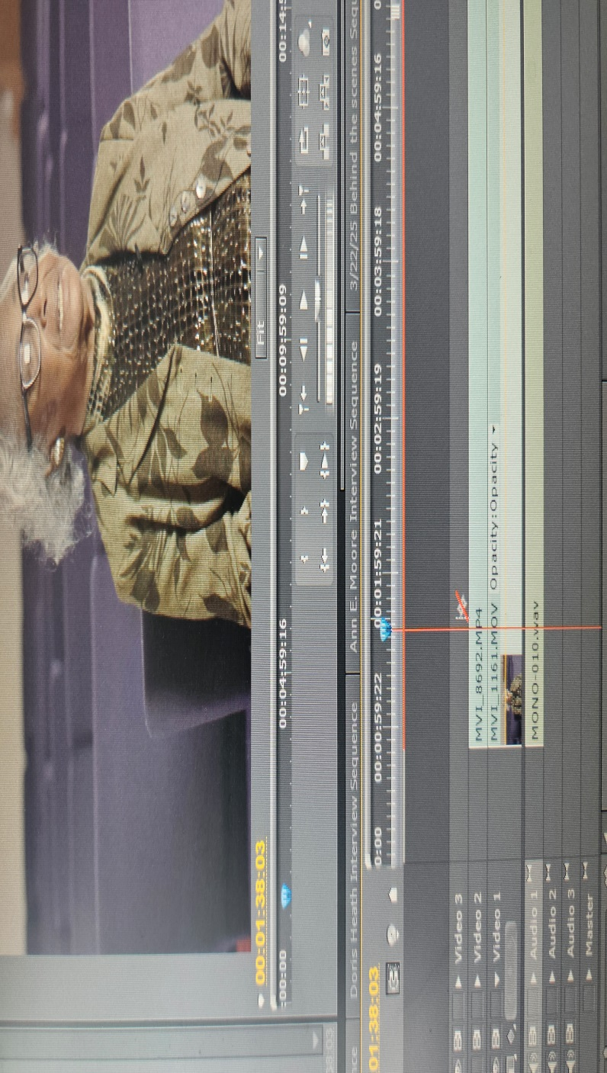
(pic 3a) listen to clip to cut interviewer out and keep interviewee’s complete sentences

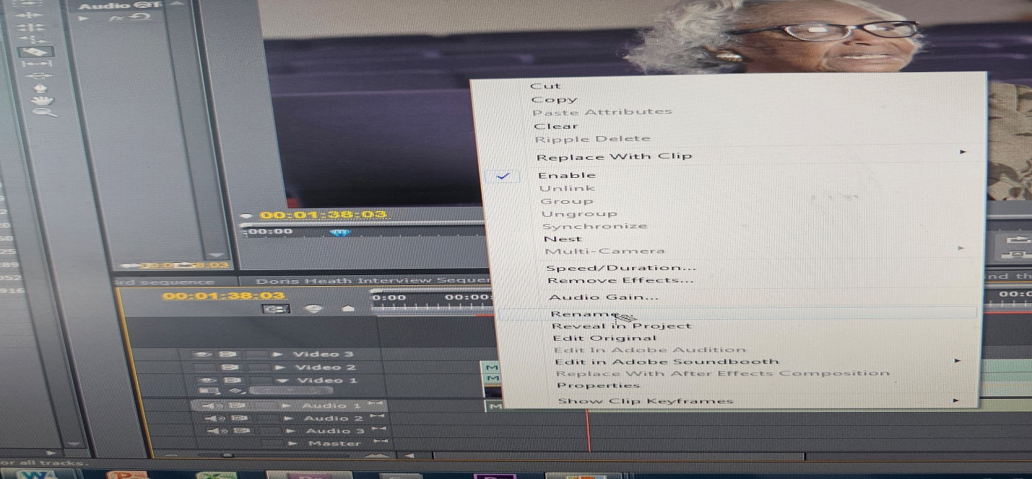
(pic 3b) cut at “out point” interviewee finished answered question right before next question and rename clips

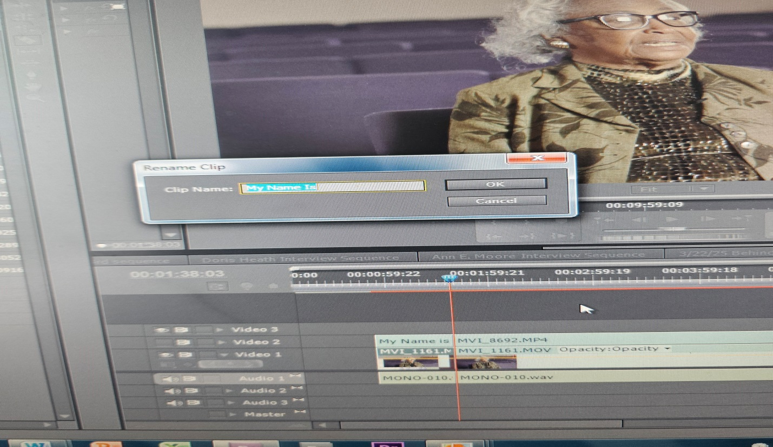
(pic 3c) on clip wanting to rename (right-click >rename) rename with a tag relevant to the question being answered

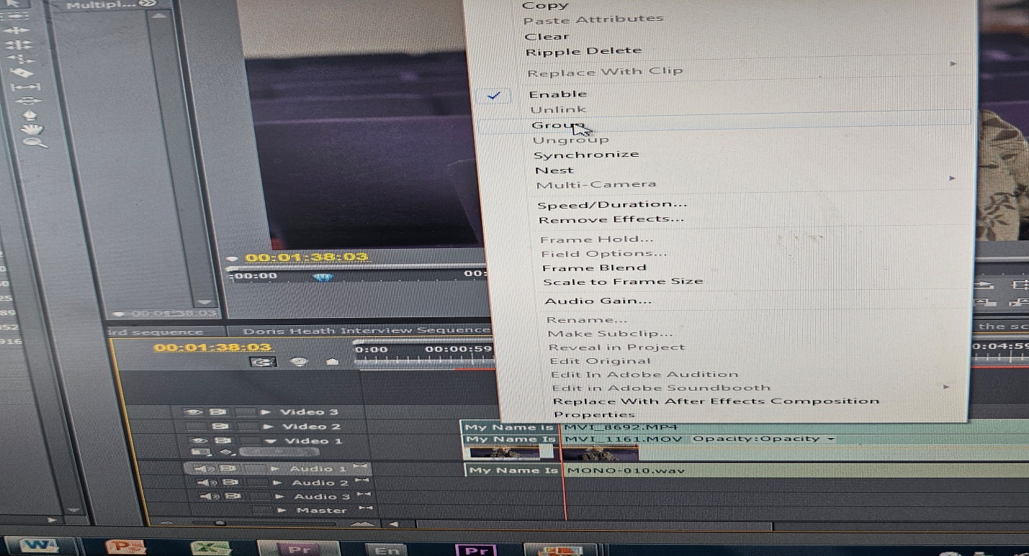
(pic 3d) once all clips are renamed select all three tracks and group together (Right-click > Group)

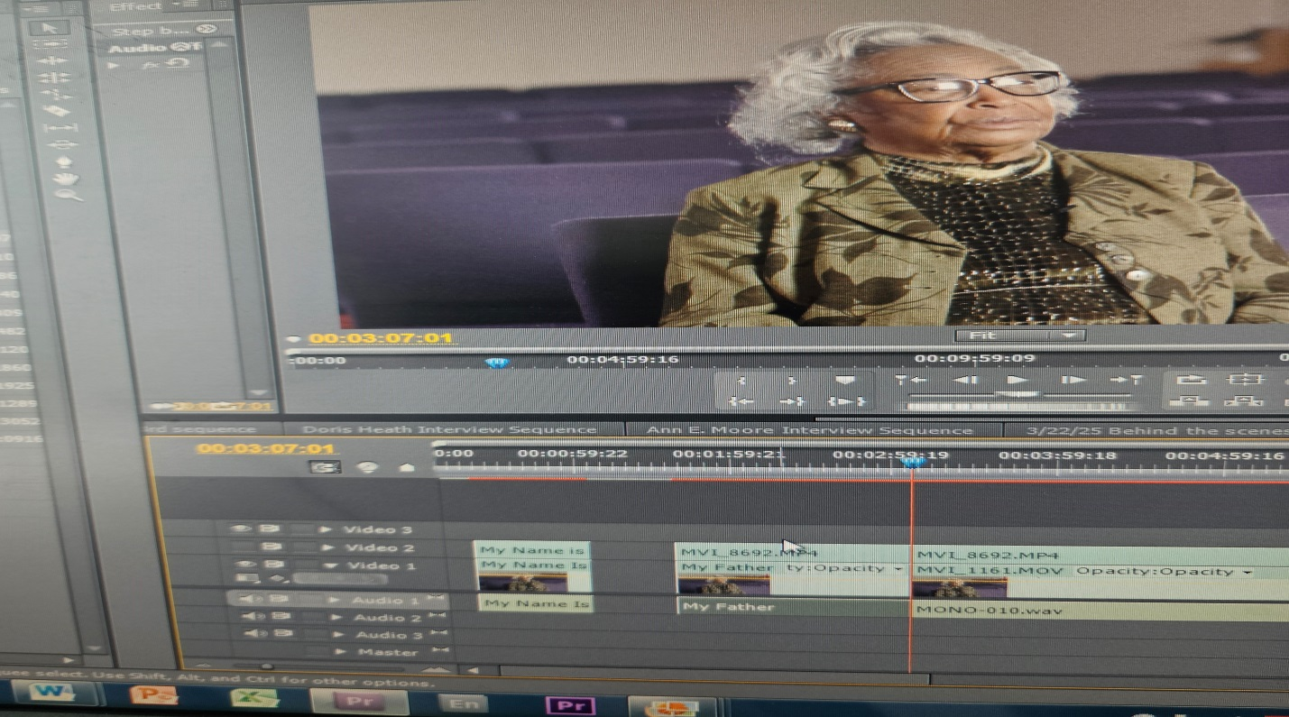
(pic 3e) continuing taking out interviewers voice and renaming and grouping clips for entire interview

